



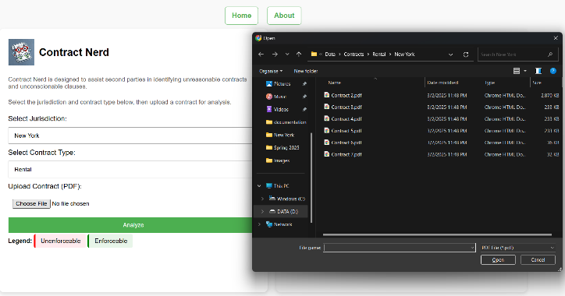


2
7
6
5
4
3
1
Database
Database
Contains gold standard contracts, state-level regulation documents, examples of risky clauses
Gold standard contract
Regulations
Risky Clauses
Linguistic Definitions
LLaMA prompt: Listing 2
LLaMA prompt: Listing 3
LLaMA prompt: Listing 3
LLaMA prompt: Listing 1
Front-end/User Interface: HTML, CSS, Javascript
Contract uploaded to be analyzed, Analysis returned
User Interface
Back-end: Python
Uploaded contract compared against stored documents/text using LLaMA prompts
Back-end

